Banking System( OOAD – Java Assignment 2025)
Title: Requirements Elicitation — Banking System (OOAD-Java Assignment 2025)
Student name: Nyasha Unami Zuva
Student number: cse24-128
Course / Module: Object-Oriented Analysis & Design (OOAD) — Java
Lecturer: KB
Assignment: Part A — Requirements Elicitation

Introduction
The document here contains all the requirements elicitation for a banking system project. Requirements were obtained via a mock interview with a representative acting as the Bank Manager. This document is organized into Functional and Non Functional Requirements. Each functional requirement includes a short description as well as actors, priority and acceptance criteria

Functional requirements
Each functional requirement includes: ID, Title, Description, Actors, Priority, Acceptance criteria.

FR-1 — Customer registration
This allows the new user of the system to register by providing personal details such as ID/ passport number, name & etc.
Actors
User and Admin
Priority: high
Acceptance Criteria : New customer record can be created and retrieved; required fields validated; unique customer ID issued.

FR-2 — Customer registration
Registered users (users and bank staff) can authenticate (username/customerID + password). Support role-based access (Customer, Clerk, Admin).
Actors
User, Bank Clerk, Admin
Priority: high
Acceptance Criteria : Valid credentials grant appropriate access; invalid credentials show an error and account locks after configurable N failed attempts.

FR-3 — Account Creation
Purpose: Allow customers to open accounts (Savings, Investment, Cheque) with relevant rules applied (e.g., Investment requires BWP 500 minimum deposit, Cheque requires employment details).

Actors
Customer, Bank Clerk
Priority: High

Acceptance Criteria : New account is registered with account number, type, and starting balance. Validation rules are enforced.

FR-4 — Deposit Transactions
Purpose: Let customers and clerks add money into accounts.
Actors: Customer, Bank Clerk
Priority: High
Acceptance Criteria : Account balance updates and a transaction record is logged.

FR-5 — Withdrawal Transactions
Purpose: Permit withdrawals from Investment and Cheque accounts. Savings accounts do not allow withdrawals.
Actors: Customer, Bank Clerk
Priority: High

Acceptance Criteria : Withdrawal reduces balance if sufficient funds exist and generates a transaction record.

FR-6 — Balance and History Enquiry
Purpose: Allow customers to view their account balances and past transactions.
Actors: Customer
Priority: High

Acceptance Criteria : System displays the correct balance and a chronological list of transactions.

FR-7 — Interest Posting
Purpose: Automatically apply monthly interest to eligible accounts (5% for Investment, 0.05% for Savings).
Actors: System, Administrator
Priority: High

Acceptance Criteria : Interest is calculated and recorded as a new transaction each month.

FR-8 — Multiple Accounts per Customer
Purpose: Support customers who own more than one account type.
Actors: Customer
Priority: High
Acceptance Criteria : A customer profile can link to several accounts.

FR-9 — Search Facility
Purpose: Allow staff to search for customers or accounts by ID, name, phone, or email.
Actors: Clerk, Administrator
Priority: Medium

Acceptance Criteria : Relevant search results are returned quickly.

FR-10 — Reporting
Purpose: Generate lists of customers, accounts by branch, and transaction histories.
Actors: Clerk, Administrator
Priority: Medium
Acceptance Criteria : Reports display accurate information and can be exported.

Non-Functional Requirements

NFR-1 — Security
Customer credentials must be protected with hashing and secure storage. Inputs should be validated to prevent common attacks.

NFR-2 — Privacy and Access Control
Sensitive customer data must only be accessible to authorized roles, with encryption applied where necessary.

NFR-3 — Performance
Core functions (login, balance check) should respond within two seconds under normal load.

NFR-4 — Availability
The application must run consistently in GitHub Codespaces for demonstration purposes.

NFR-5 — Accuracy
Financial calculations (interest, deposits, withdrawals) must be precise and error-free.

NFR-6 — Usability
The interface should be intuitive, requiring minimal steps to complete common tasks. Only access system when online.

NFR-7 — Maintainability
The system should follow modular design principles with separate layers for view, logic, and data.

NFR-8 — Testability
Business logic must be testable independently from the interface, with unit tests for major functions.

NFR-9 — Accessibility
Forms and inputs must include basic labels and keyboard navigation for accessibility.

UML DIAGRAMS
Class Diagram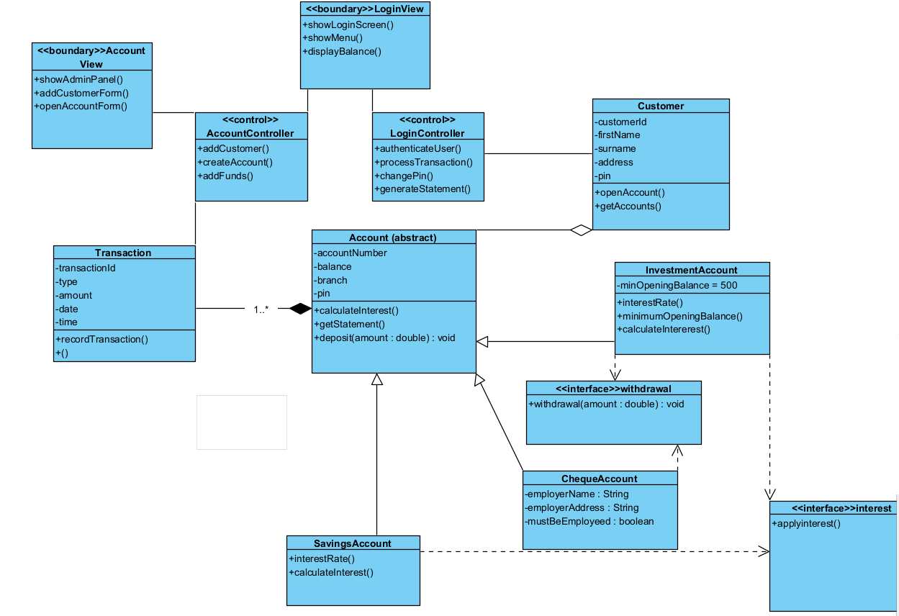

USE CASE DIAGRAM

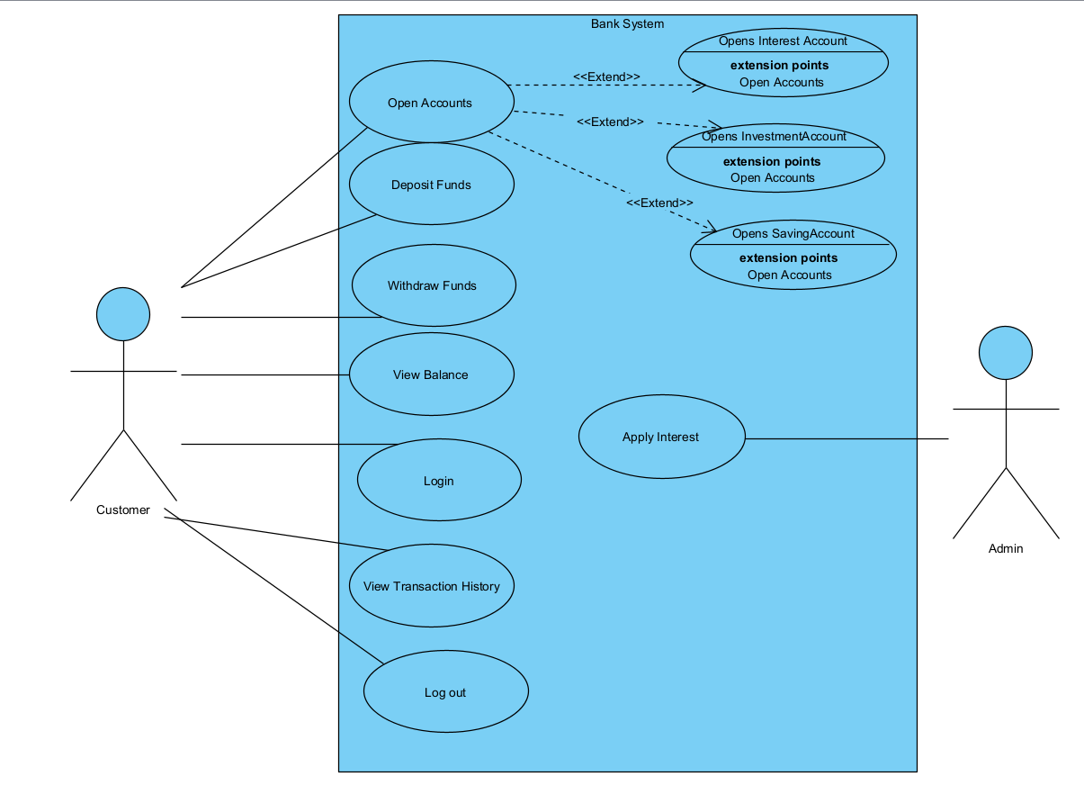

Sequence Diagrams
Login System

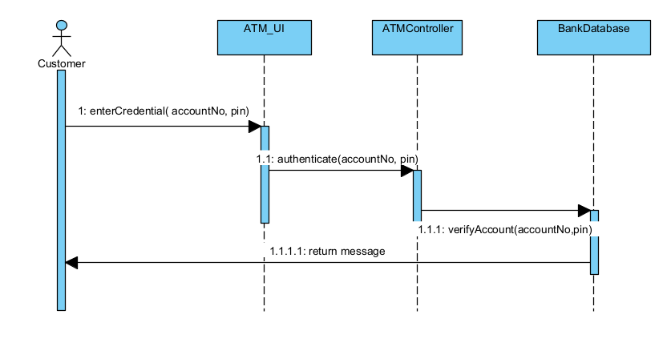
Deposit

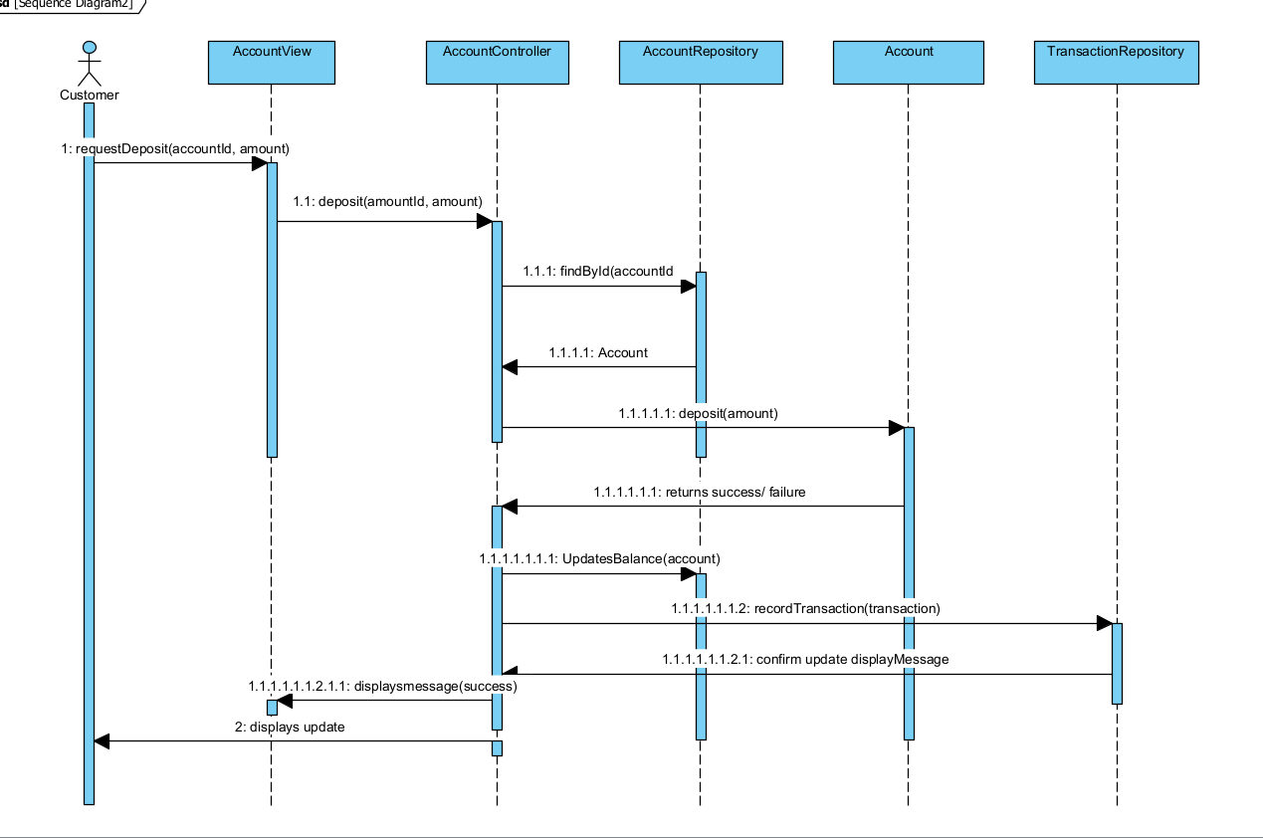STATE DAIGRAM
Investment Account Class

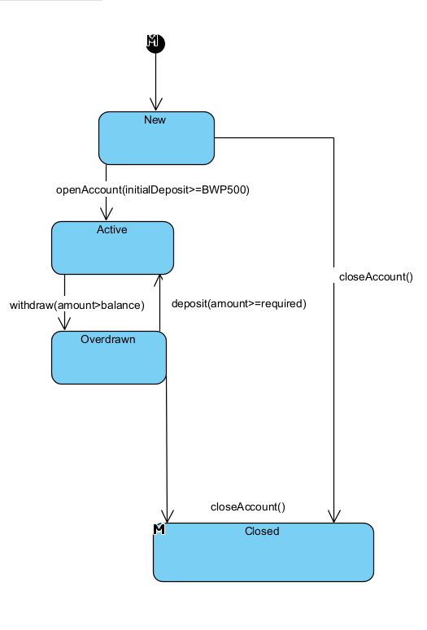

Interview Record
Title: Interview for Requirements Elicitation — Banking System
Date: September 18, 2025
Location: Room 5
Interviewer: Nyasha Unami Zuva (Student Developer)
Interviewee: Mr. Themba Moeng (Lecturer, acting as Bank Manager)
Transcript (Edited for Clarity)

Q1: Who will use the system?
A1: Customers, clerks, and administrators.

Q2: The brief mentions three account types (Savings, Investment, Cheque). Should the system support only these or allow others?
A2: Only those three types are required. However, a customer may own multiple accounts.

Q3: What are the main operations a customer should be able to perform?
A3: Besides login and logout, customers must be able to view their accounts, search for a specific account, withdraw or deposit where permitted, check balances, and view transaction history within a date range.

Q4: How should the system keep records of all customers to allow easy retrieval and management?
A4: The system should use a database management system (such as Oracle, MySQL, or MariaDB). All entity classes (accounts, customers, transactions) should be stored as tables in the database.

Q5: How should interest be calculated and applied to accounts?
A5: Interest is applied based on the stated percentages (5% for Investment, 0.05% for Savings). It won’t be fully automated — a bank employee will trigger the calculation at a set time each month by clicking a “Calculate Interest” button. The system will then update balances accordingly.

Q6: Are there any rules or constraints that must be enforced for accounts?
A6: Yes. For Investment accounts, the minimum deposit must remain intact; withdrawals cannot reduce the balance below that. In all accounts, overdrawing is not allowed — no negative balances.

Q7: Why is it necessary for clients to provide workplace details when opening a Cheque account?
A7: This is due to financial regulations — the bank must verify the source of income.

Q8: What security rules must the system follow?
A8: All users must have a username and password. Passwords must be at least 8 characters long and include both letters and numbers.

Q9: Should the system’s interface be simple or more interactive?
A9: Since it will be used by the public, it must be simple and user-friendly, requiring no training. It should provide feedback messages (e.g., login errors, confirmation of deposits/withdrawals, search results found or not found).

Q10: Does the system need offline access?
A10: No, it should always be online. Offline functionality is not required.

From this interview, the functional and non-functional requirements of the system were identified. The client confirmed that only three account types (Savings, Investment, Cheque) are required, that customers can have multiple accounts, and that interest must be manually triggered each month. Constraints such as minimum balances and employment details for cheque accounts were also confirmed. Security rules and usability expectations were also discussed

